**DL Lab Assignment 04**

Importing libraries

import matplotlib.pyplot as plt

import pandas as pd

import tensorflow as tf

import seaborn as sns

from tensorflow.keras.models import Model

from sklearn.metrics import accuracy_score, precision_score, recall_score

from sklearn.model_selection import train_test_split

from keras import Sequential

sns.set()

import numpy as np

from tensorflow.keras import layers, losses

Importing data and Checking the data

df = pd.read_csv('http://storage.googleapis.com/download.tensorflow.org/data/ecg.csv', header=None)

raw_data = df.values

df.head()

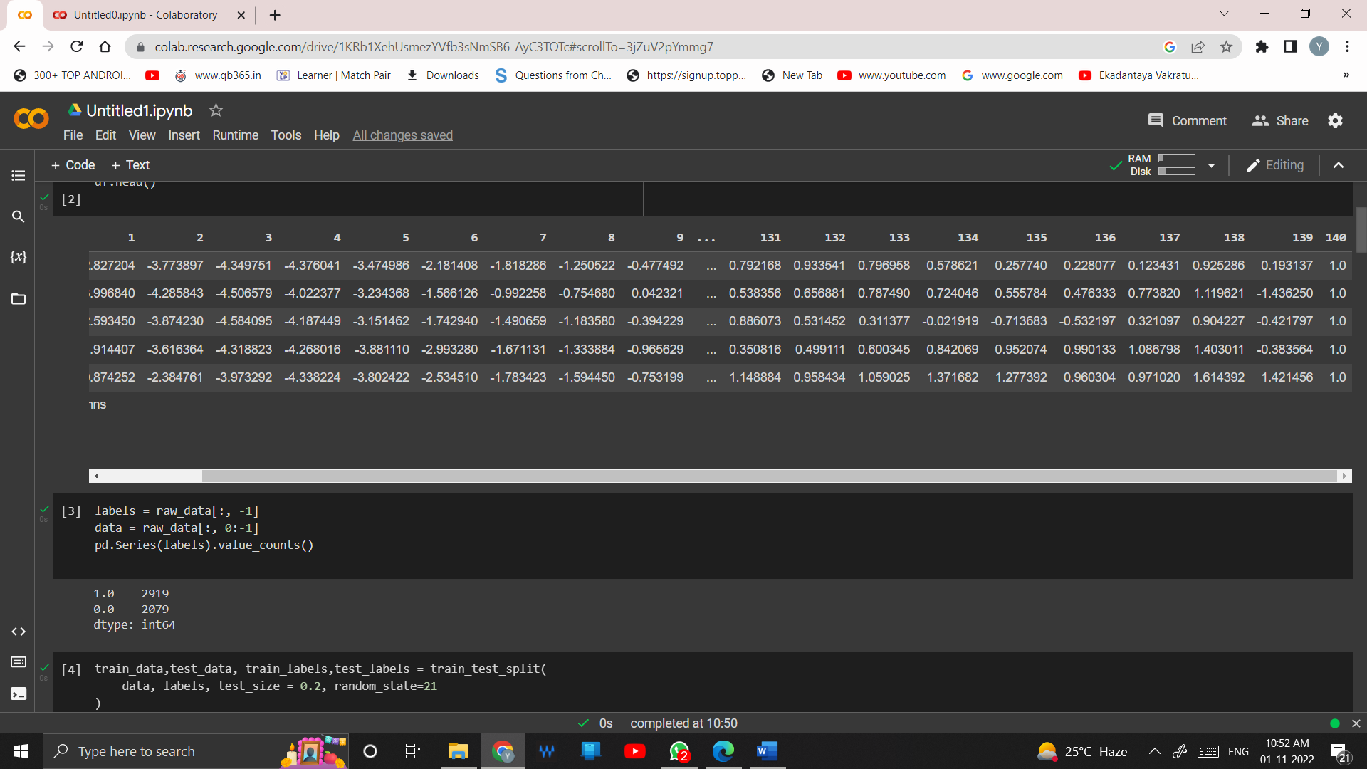

Splitting the data and labels

labels = raw_data[:, -1]

data = raw_data[:, 0:-1]

pd.Series(labels).value_counts()

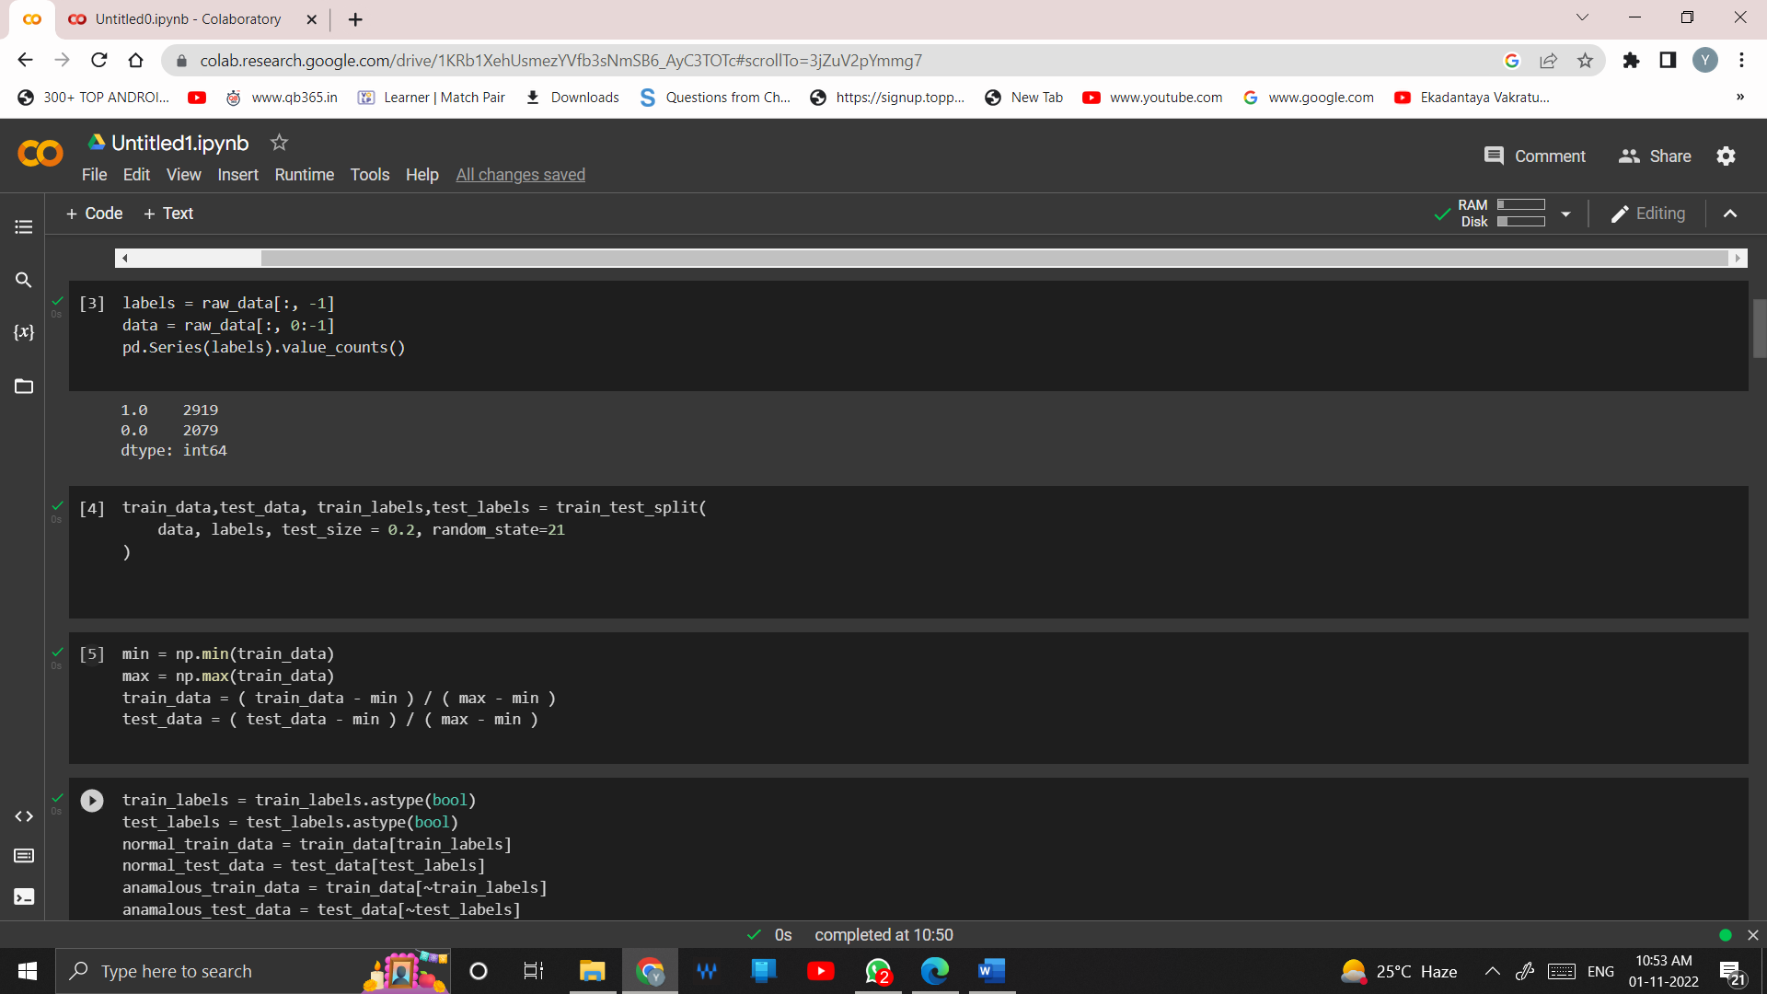

Splitting the training and testing data

train_data,test_data, train_labels,test_labels = train_test_split(

data, labels, test_size = 0.2, random_state=21

)

Structuring the data

min = np.min(train_data)

max = np.max(train_data)

train_data = ( train_data - min ) / ( max - min )

test_data = ( test_data - min ) / ( max - min )

**Dividing the data using true / false value**

train_labels = train_labels.astype(bool)

test_labels = test_labels.astype(bool)

normal_train_data = train_data[train_labels]

normal_test_data = test_data[test_labels]

anamalous_train_data = train_data[~train_labels]

anamalous_test_data = test_data[~test_labels]

**Printing Values**

~train_labels

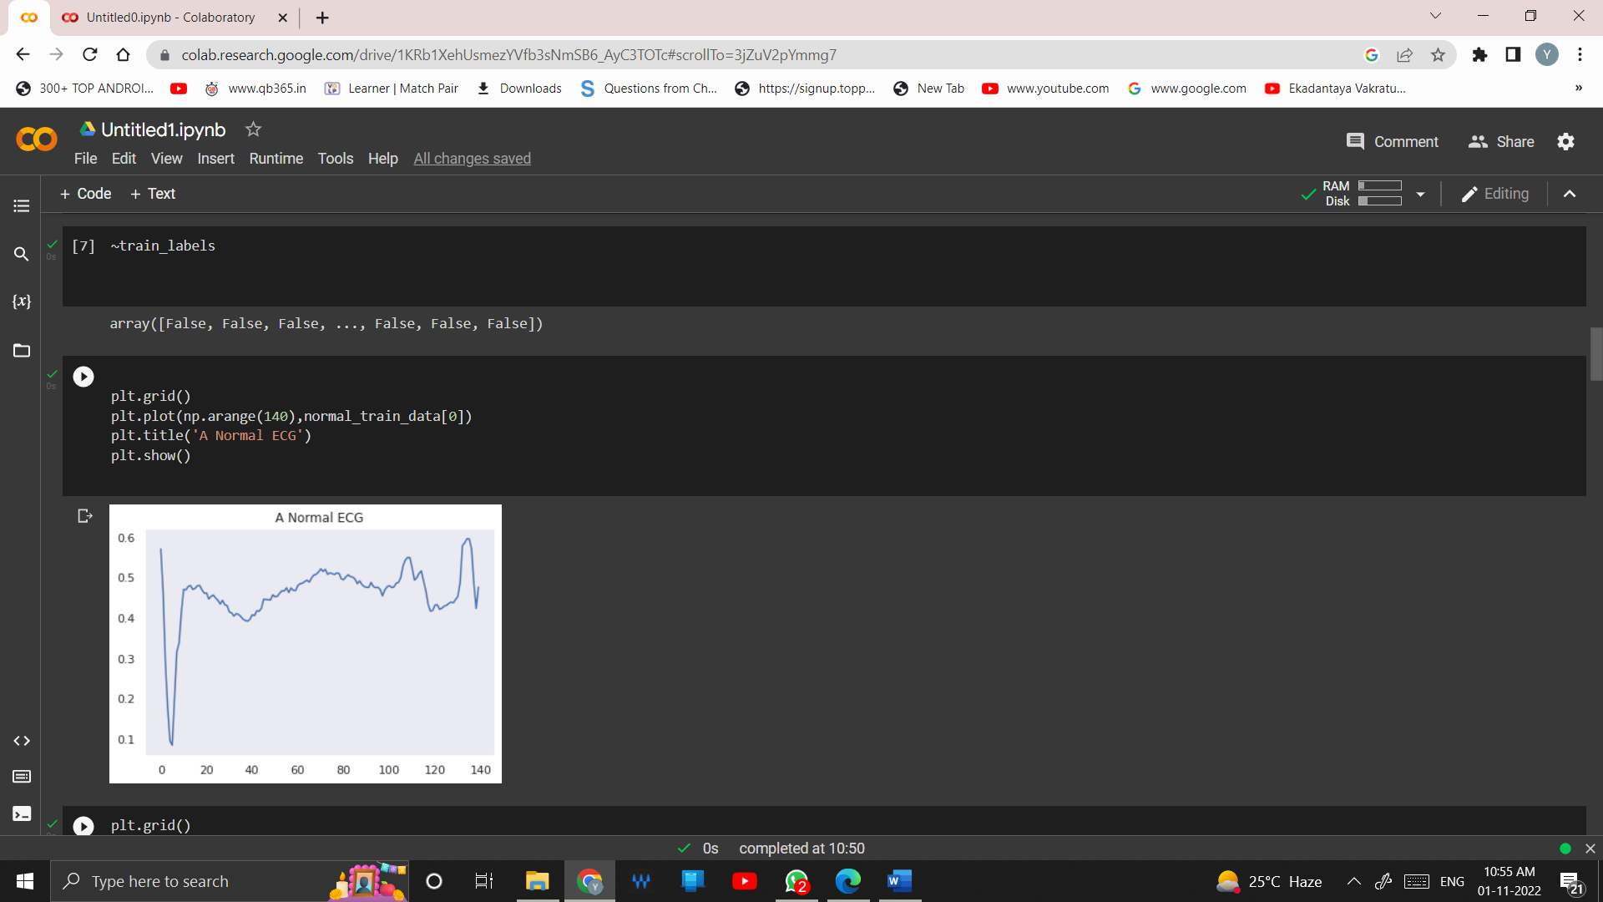

**Plotting normal ECG**

plt.grid()

plt.plot(np.arange(140),normal_train_data[0])

plt.title('A Normal ECG')

plt.show()

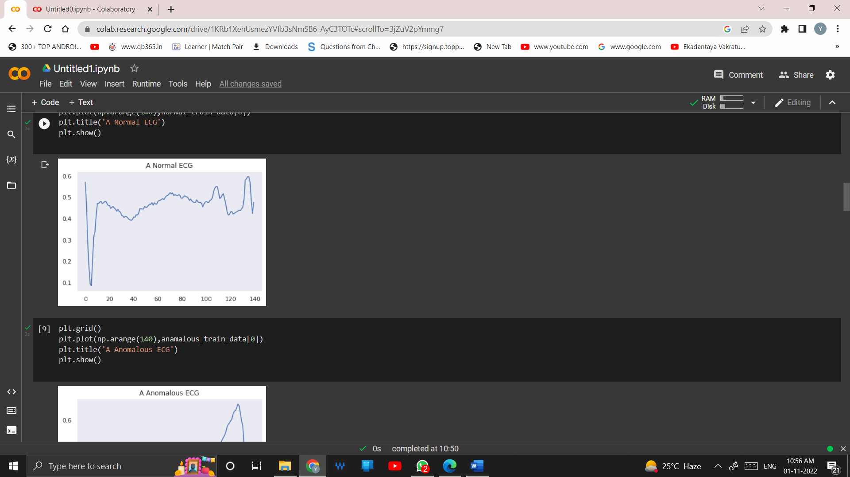

**Plotting a anomalous ECG**

plt.grid()

plt.plot(np.arange(140),anamalous_train_data[0])

plt.title('A Anomalous ECG')

plt.show()

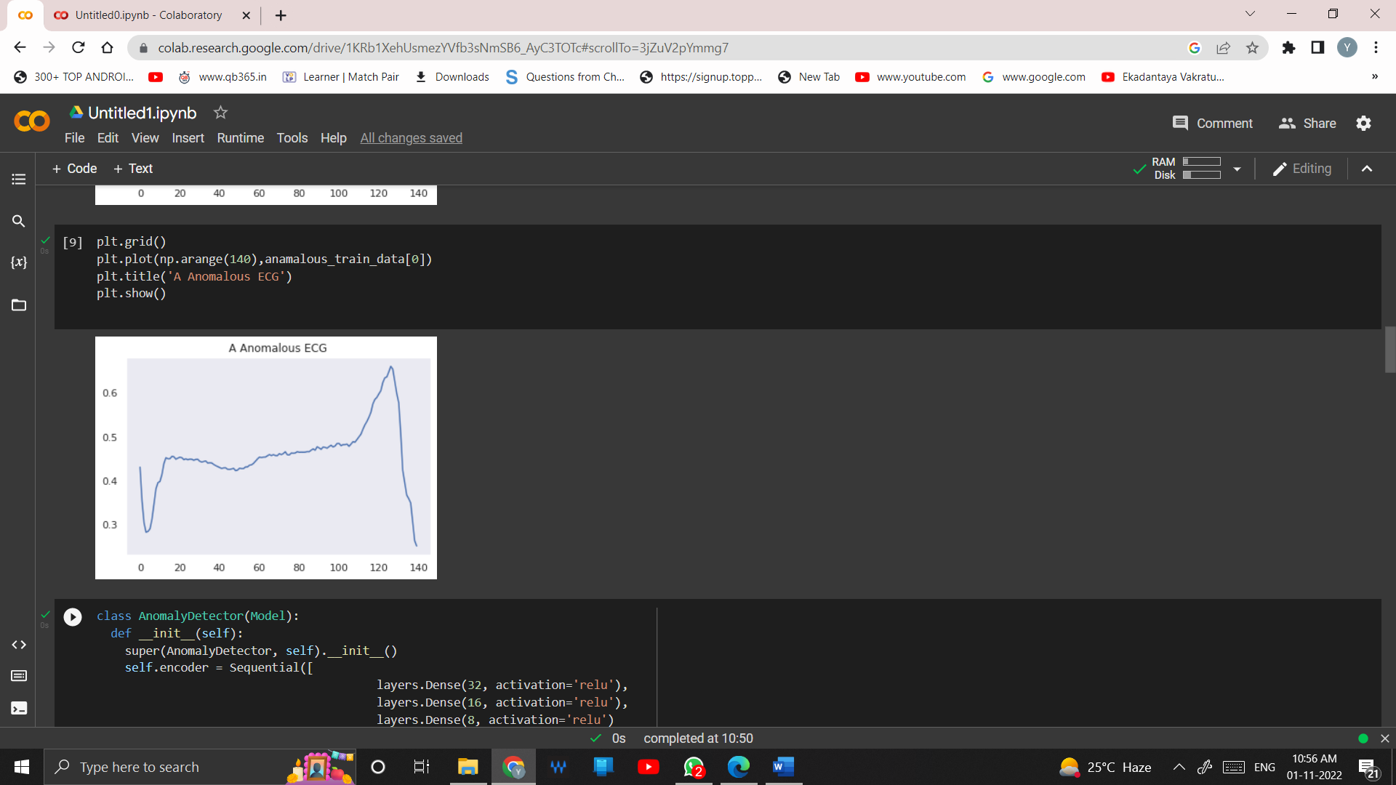

**Model Building**

class AnomalyDetector(Model):

def __init__(self):

super(AnomalyDetector, self).__init__()

self.encoder = Sequential([

layers.Dense(32, activation='relu'),

layers.Dense(16, activation='relu'),

layers.Dense(8, activation='relu')

])

self.decoder = tf.keras.Sequential([

layers.Dense(16, activation='relu'),

layers.Dense(32, activation='relu'),

layers.Dense(140, activation='sigmoid')

])

def call(self, x):

encoded = self.encoder(x)

decoded = self.decoder(encoded)

return decoded

autoencoder = AnomalyDetector()

**Compiling model using loss function and optimizer**

autoencoder.compile(optimizer='adam', loss='mae')

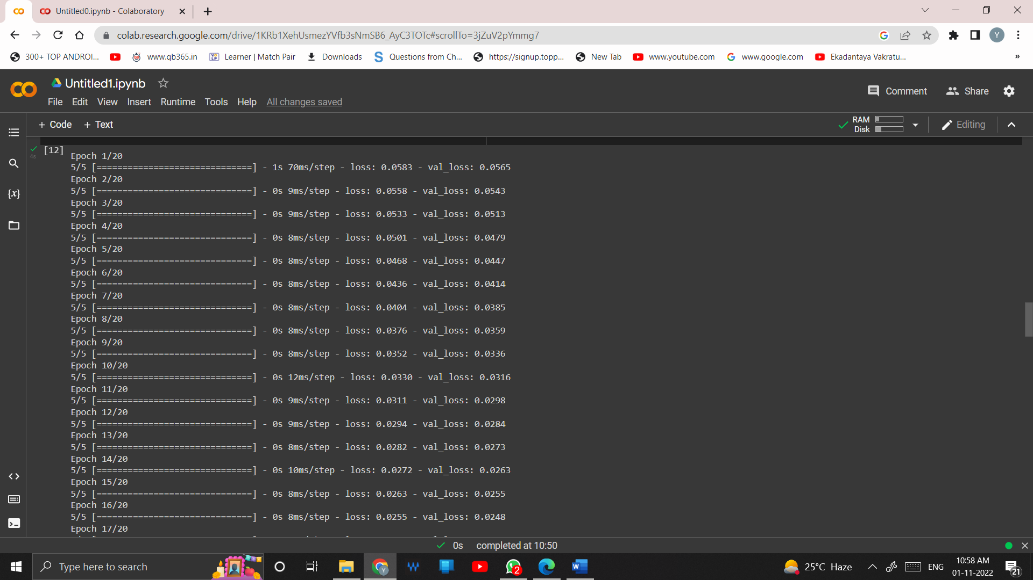

**Fitting the data**

history = autoencoder.fit(normal_train_data, normal_train_data,

epochs = 20,

batch_size=512,

validation_data=(normal_test_data, normal_test_data),

shuffle=True)

Plotting the difference between loss and validation loss of data

plt.plot(history.history['loss'],label='Training Loss')

plt.plot(history.history['val_loss'],label='Testing Loss')

plt.legend()

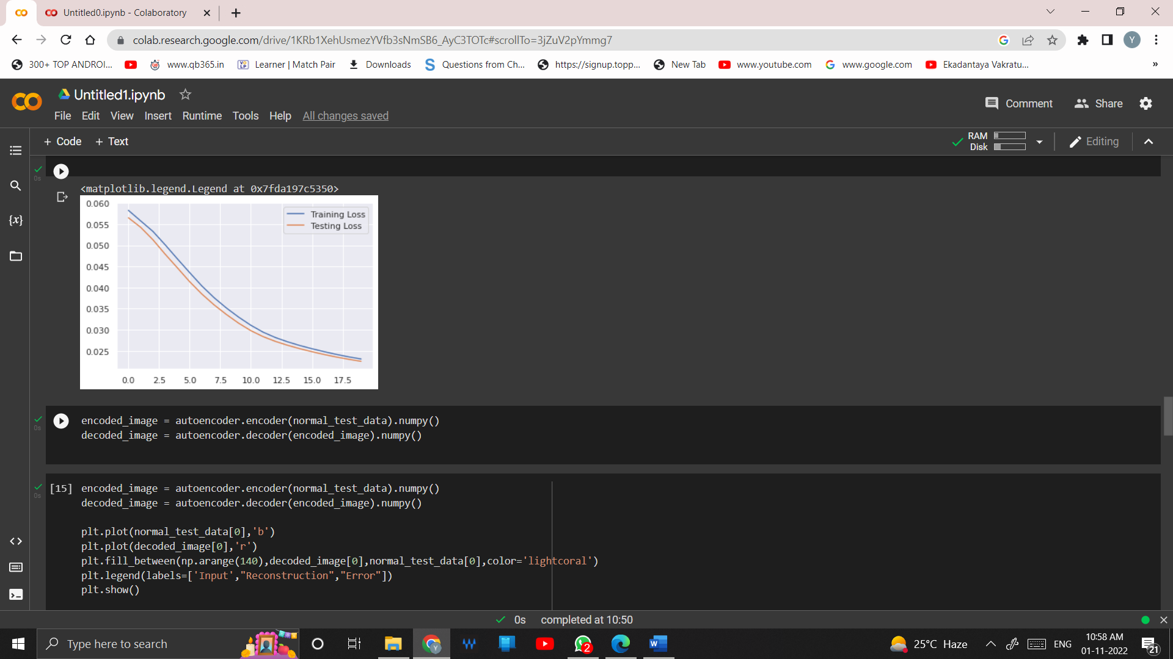

**Plotting the difference between input and reconstruction and error or normal test data set**

encoded_image = autoencoder.encoder(normal_test_data).numpy()

decoded_image = autoencoder.decoder(encoded_image).numpy()

plt.plot(normal_test_data[0],'b')

plt.plot(decoded_image[0],'r')

plt.fill_between(np.arange(140),decoded_image[0],normal_test_data[0],color='lightcoral')

plt.legend(labels=['Input',"Reconstruction","Error"])

plt.show()

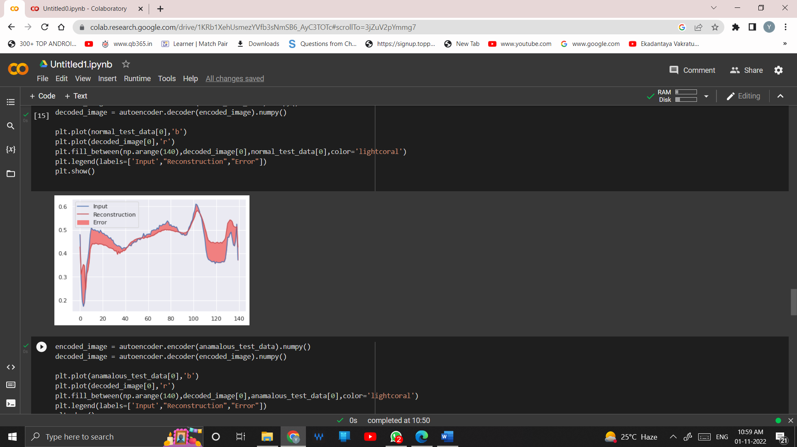

**Plotting the difference between input and reconstruction and error or anomalous test data set**

encoded_image = autoencoder.encoder(anamalous_test_data).numpy()

decoded_image = autoencoder.decoder(encoded_image).numpy()

plt.plot(anamalous_test_data[0],'b')

plt.plot(decoded_image[0],'r')

plt.fill_between(np.arange(140),decoded_image[0],anamalous_test_data[0],color='lightcoral')

plt.legend(labels=['Input',"Reconstruction","Error"])

plt.show()

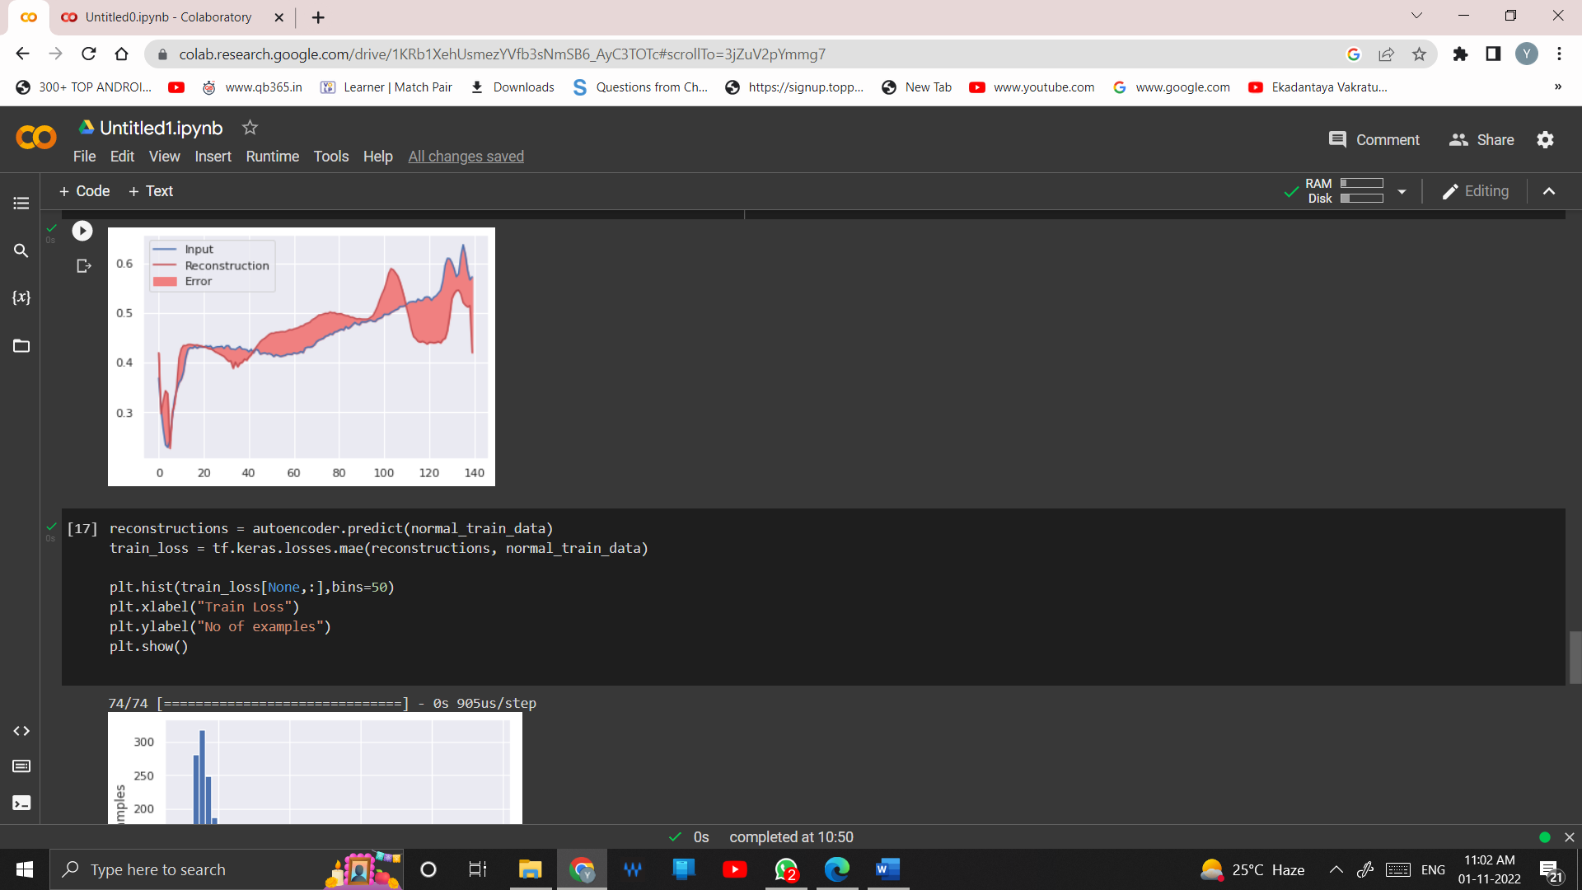

**Plotting histogram prediction for normal test data**

reconstructions = autoencoder.predict(normal_train_data)

train_loss = tf.keras.losses.mae(reconstructions, normal_train_data)

plt.hist(train_loss[None,:],bins=50)

plt.xlabel("Train Loss")

plt.ylabel("No of examples")

plt.show()

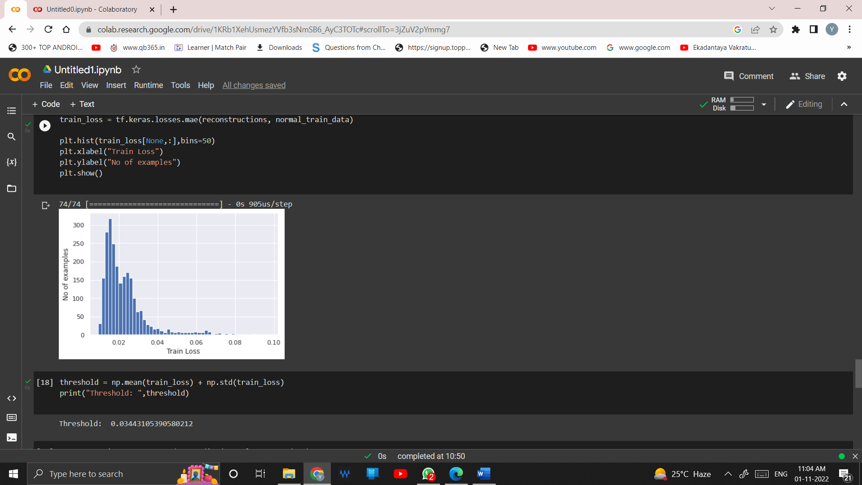

**Threshold value**

threshold = np.mean(train_loss) + np.std(train_loss)

print("Threshold: ",threshold)

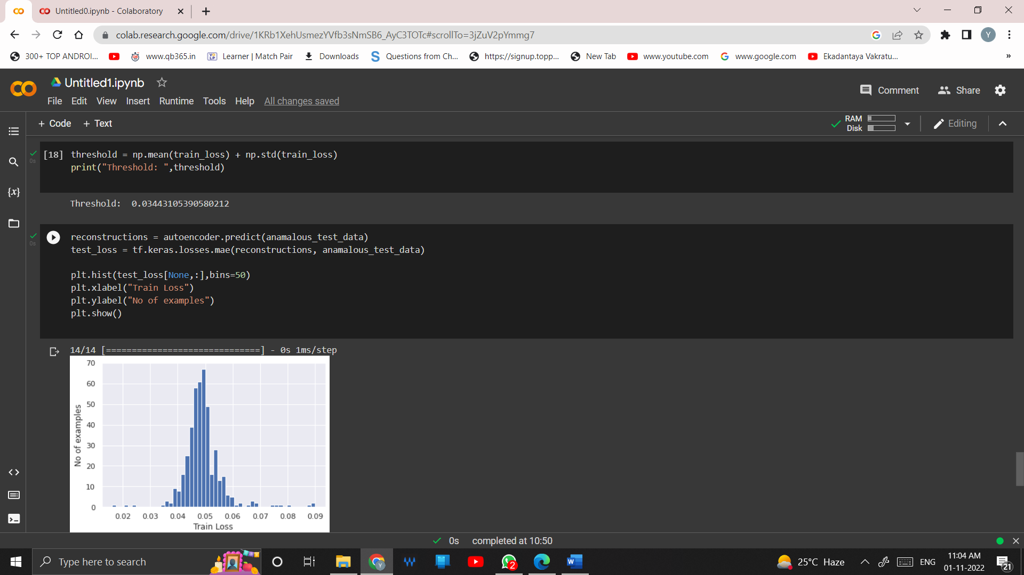

Plotting histogram for prediction of anomalous test data

reconstructions = autoencoder.predict(anamalous_test_data)

test_loss = tf.keras.losses.mae(reconstructions, anamalous_test_data)

plt.hist(test_loss[None,:],bins=50)

plt.xlabel("Train Loss")

plt.ylabel("No of examples")

plt.show()

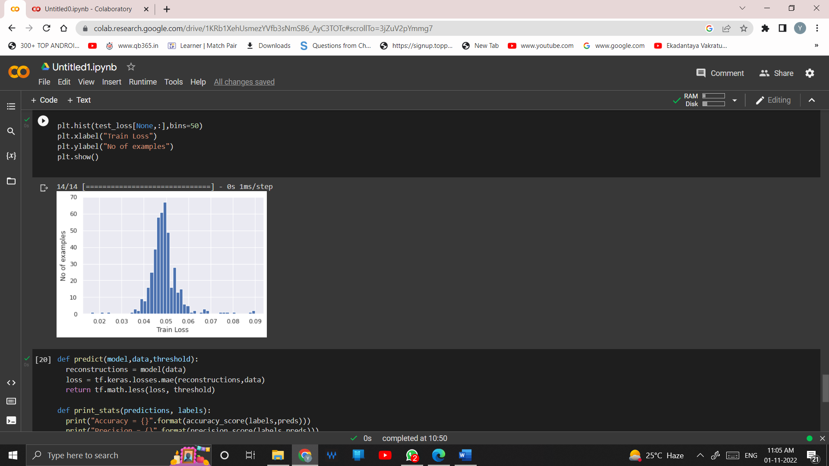

**Predicting the Accuracy**

def predict(model,data,threshold):

reconstructions = model(data)

loss = tf.keras.losses.mae(reconstructions,data)

return tf.math.less(loss, threshold)

def print_stats(predictions, labels):

print("Accuracy = {}".format(accuracy_score(labels,preds)))

print("Precision = {}".format(precision_score(labels,preds)))

print("Recall = {}".format(recall_score(labels,preds)))

preds = predict(autoencoder, test_data, threshold)

print_stats(preds, test_labels)

